**Client Context**

|  |  |
| --- | --- |
| **OPTIMISING SUPPORTER JOURNEYS FOR WORLD VISION AUSTRALIA’S BOUNCEBACK CAMPAIGN** | **MIS779 – Decision Analytics in Practice. Part B(Group) – Client Brief**  **Group: Team 23**  **AJAY RAO JHADE- 223769878**  **ANAGHA PRASHANTH RAJE URS- 223709844**  **HARGUN KAUR- 223112868**  **JOHAN JACOB FRANCIS- 223885443**  **KIRAN MOOLETTU SIBY- 223748571**  **SHAMBHAVI ADHIKARI- 223561357** |

World Vision Australia (WVA) supports vulnerable children through donor-funded programs. Its Bounceback Campaign seeks to re-engage lapsed donors but follows a uniform seven-message approach, ignoring donor diversity. To enhance retention, WVA must adopt a personalized, data-driven strategy that considers engagement history, emotional triggers, and giving capacity.

**Business Model and Revenue Sources**

The Bounceback Campaign runs on a donation-based model, with supporters contributing $48 per month per child. Revenue channels include Direct Mail, Online, Retail, Retail EV, and SSG. Seasonal appeals like Birthday and Christmas Cards generate the highest revenue, with coupons yielding the best returns (refer Fig.1 ). Key donor personas—Leading Lifestyles, Home and Hearth, and Metrotechs—highlight the need for tailored engagement (Fig 2). Competitors use subscription models and corporate sponsorships to boost retention. To stay competitive, WVA must leverage AI-driven donor insights, automate donor engagement, and diversify funding sources, ensuring long-term donor commitment and impact.

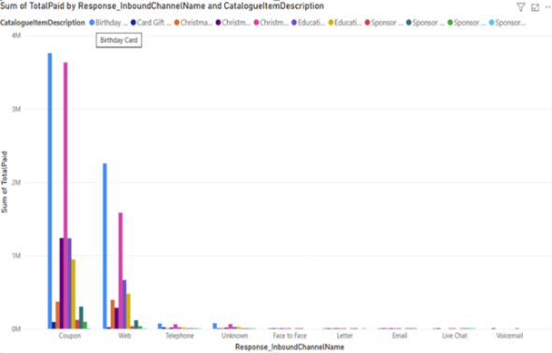

Fig 1. Birthday cards and Christmas cards as highest Revenue Streams in the Channels blue and pink respectively via coupons

**Team’s Interpretation**  
World Vision Australia’s Bounceback campaign uses a fixed communication model, sending all donors the same seven messages, regardless of their engagement, history, or giving capacity. This approach overlooks the diverse needs, preferences, and emotional readiness of different supporter groups.

Figure 2. Helix and Lewers Persona Segments Fig 3. Blue signifies Bounceback contacted and orange signifies Outcome Card Received

* **Uniform messaging:** High-value and engaged supporters receive the same content and timing as low-engagement or first-time donors.
* **Missing emotional impact:** Emotional moments like child letters or birthday messages are sent without any follow-up, reducing their long-term impact.
* **Lack of personalization:** The communication style and journey are not adapted based on past interactions or supporter intent. Fig 3. Shows a significant gap between the number of people contacted ("Bounceback Contacted") and those who responded ("Outcome Card Received")

**Addressability of the Problem**

Although WVA holds valuable data—such as donation history, supporter engagement levels, and contact frequency, this information is not fully utilised to tailor donor journeys. Although WVA holds valuable data—such as donation history, supporter engagement levels, and contact frequency, this information is not fully utilized to tailor donor journeys. The existing segmentation, which broadly classifies supporters based on response history and communication preferences, which is too broad to capture the diversity of donor behavior (refer Fig 4.)

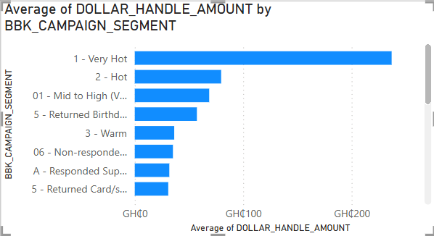

Figure 4. Donation Ask by Campaign Engagement Segment Fig 5. Non-Responding Supporters by Communication Channel Phase

**Impact of the Problem**

This gap between communication strategy and supporter needs has direct and measurable consequences:

* Donors may become disengaged due to repetitive or irrelevant messages, with online channels (e.g., email and SMS) showing higher non-response rates compared to offline channels (e.g., direct mail), as shown in Figure 5.
* High-potential donors are not prioritised, despite contributing more than $70 on average in previous campaigns, reducing opportunities for deeper engagement and increased giving
* Emotional connections are not reinforced, with minimal follow-up seen on high-impact moments like child letters or birthdays, weakening long term relationships.
* The campaign’s potential to drive re-engagement and revenue is limited by a lack of personalization, as demonstrated by the significant drop-off between initial contact and donation response in several journey phases.

**Limitations**

* **Limited Access & Understanding:** Restricted client access and no direct user engagement limit feedback and donor insights.
* **Data & Tracking Gaps:** Poor data quality, missing engagement metrics, and channel differentiation issues hinder personalization.
* **ROI Uncertainty:** Unclear coupon attribution and missing investment data complicate ROI analysis, requiring alternative metrics.

**Team-Specific Focus**

Our team focuses on **Journey Optimization**, ensuring donor communications are timely, relevant, and effective. Key priorities include:

* **Data Standardization:** Addressing inconsistencies (e.g., variations in donation categories) to improve segmentation accuracy.
* **Personalized Engagement:** Using predictive modelling and donor personas to refine communication timing, sequencing, and channel selection.
* **Optimized Donation Asks:** Experimenting with flexible approaches to boost retention and response rates.

To strengthen donor relationships and long-term impact: Insights from Audience, Contacted, and Responses datasets revealed inconsistent segmentation, drop-off trends, and ask-value misalignment across donor types.  
• Our analysis of these metrics - channel response rates, donation values by segment, and engagement by age and tenure has informed areas for refinement in donor journey design.

• Our next steps involve creating visual journey maps and measuring success through engagement rate, donation uplift, and segment-wise retention to inform campaign redesign.